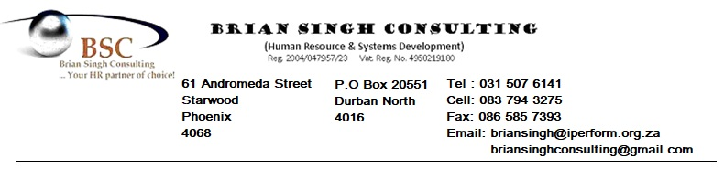

THE PROTECTION OF PERSONAL INFORMATION ACT - CUSTOMER PRIVACY NOTICE

Dear Valued Client

**At Brian Singh Consulting CC we are committed to protecting your privacy.**

**We respect your right to privacy and therefore aim to ensure that we comply with the legal requirement of the POPI Act which regulates the manner in which we collect, process, store, share and destroy any personal information which you have provided to us.**

**OUR POLICY**

**Definition of personal information**

According to the Act ‘‘personal information’’ means information relating to an identifiable, living, natural person, and where it is applicable, an identifiable, existing juristic person.

**The information we collect**

We collect and process your personal information from your employer or directly from you. This is for the purposes of organizational development for the organization you are employed by. We collect information directly from you where you provide us with your personal details, through various mediums such as our online questionnaires or attendance registers which require your details. Information collected from your employer includes your personal details. This information is captured in the form of staff establishments, employment contracts etc.

Website usage information may be collected using “cookies” which allows us to collect standard internet visitor and mobile app usage information.

**How we use your information**

Personal Information is used only for the legitimate purpose for which it was provided (Organizational Development) and it will not be shared with third parties or used for marketing purposes.

**Information Security**

We are legally obliged to provide adequate protection for the personal information we hold and to stop unauthorized access and use of personal information. We will, on an on-going basis, continue to review our security controls and related processes to ensure that your personal information remains secure.

We will take all reasonable steps to ensure that your personal information is protected. We protect and manage personal information that we hold about you by using electronic and computer safeguards like firewalls, data encryption, and physical and electronic access control to our buildings. We only authorize access to personal information to those employees who require it to fulfil their designated responsibilities

**Your Rights: Access to information**

You have the right to request a copy of the personal information we hold about you. You have the right to ask us to update, correct or delete your personal information.

If you have any questions about this notice; you need further information about our privacy practices; wish to withdraw consent; exercise preferences or access or correct your personal information, please contact us at the numbers/addresses listed on our website.

We welcome any queries or concerns you may have.

Regards,

Brian Singh Consulting